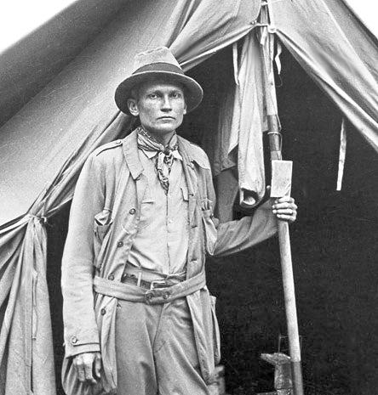
Hiram Bingham, 1911, Peru

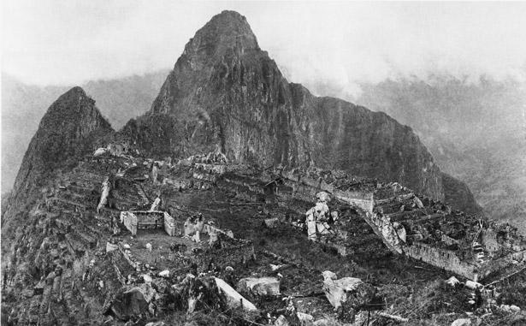
Hiram’s first view of Machu Picchu in 1911

By Kelly Hearn and Jason Golomb

On the morning of July 24, 1911, a tall lecturer-cum-explorer from Yale University set off in a cold drizzle to investigate rumors of ancient Inca ruins in Peru. The explorer chopped his way through thick jungle, crawled across a "bridge" of slender logs bound together with vines, and crept through underbrush hiding venomous fer-de-lance pit vipers.
Two hours into the hike, the explorer and his two escorts came across a grass-covered hut. A pair of Indian farmers walked them a short way before handing them over to a small Indian boy. With the boy leading the way, Hiram Bingham stumbled upon one of the greatest archaeological finds of the 20th century—and what was named in 2007 as one of the new seven wonders of the world: Machu Picchu.
What Bingham saw was a dramatic and towering citadel of stone cut from escarpments. Fashioned by men without mortar, the stones fit so tightly together that not even a knife's blade could fit between them. He wondered: Why? By whom? For what?
Certainly, what he saw was awe-invoking. Contemporary Peruvian expert Luis Lumbreras, the former director of Peru's National Institute of Culture, describes "a citadel made up of palaces and temples, dwellings and storehouses," a site fulfilling ceremonial religious functions.
Machu Picchu is formed of buildings, plazas, and platforms connected by narrow lanes or paths. One sector is cordoned off to itself by walls, ditches, and, perhaps, a moat—built, writes Lumbreras, "not as part of a military fortification [but] rather as a form of restricted ceremonial isolation."
The Wrong "Lost City"
Bingham's discovery was published in the April 1913 issue of National Geographic magazine, bringing the mountaintop citadel to the world's attention. (The National Geographic Society helped fund Bingham on excursions to Machu Picchu in 1912 and 1915.)
Bingham believed he had found Vilcabamba, the so-called Lost City of the Inca where the last of the independent Inca rulers waged a years-long battle against Spanish conquistadors. Bingham argued for and justified his conclusions for almost 50 years after his discovery, and his explanations were widely accepted.
What Bingham had found, however, was not the lost city, but a lost city.
In 1964, adventurer Gene Savoy identified ruins and proved that Espiritu Pampa (in the Vilcabamba region of Peru, west of Machu Picchu) was the lost city that Bingham had originally sought. Ironically, Bingham had actually discovered these ruins at Espiritu Pampa during his 1911 trek. He uncovered a few Inca-carved stone walls and bridges but dismissed the ruins and ultimately focused on Machu Picchu. Savoy uncovered much of the rest.
So what then was this city that Bingham had revealed? There were no accounts of Machu Picchu in any of the much-studied chronicles of the Spanish invasion and occupation. There was nothing to document that it even existed at all, let alone its purpose.
Bingham theorized that Machu Picchu had served as a convent of sorts where chosen women from the Inca realm were trained to serve the Inca leader and his coterie. He found more than a hundred skeletons at the site and believed that roughly 75 percent of the skeletons were female, but modern studies have shown a more reasonable fifty-fifty split between male and female bones.
Bingham also believed that Machu Picchu was the mythical Tampu-tocco, the birthplace of the Inca forefathers.
Modern Theories
Modern research has continued to modify, correct, and mold the legend of Machu Picchu. Research conducted by John Rowe, Richard Burger, and Lucy Salazar-Burger indicates that rather than being a defensive stronghold, Machu Picchu was a retreat built by and for the Inca ruler Pachacuti. Burger has suggested it was built for elites wanting to escape the noise and congestion of the city.
Brian Bauer, an expert in Andean civilization at the University of Illinois at Chicago and a National Geographic grantee, says Machu Picchu—which was built around A.D. 1450—was, in fact, relatively small by Inca standards and maintained only about 500 to 750 people.
One thing is certain, says Bauer, archaeological evidence makes it clear that the Inca weren't the only people to live at Machu Picchu. The evidence shows, for instance, varying kinds of head modeling, a practice associated with peoples from coastal regions as well as in some areas of the highlands. Additionally, ceramics crafted by a variety of peoples, even some from as far as Lake Titicaca, have been found at the site.
"All this suggests that many of the people who lived and died at Machu Picchu may have been from different areas of the empire," Bauer says.
As for farming, Machu Picchu's residents likely made use of the grand terraces surrounding it. But experts say these terraces alone couldn't have sustained the estimated population of the day and that farming most likely also took place in the surrounding hills.
Dr. Johan Reinhard, a National Geographic explorer-in-residence, has spent years studying ceremonial Inca sites at extreme altitudes. He's gathered information from historical, archaeological, and ethnographical sources to demonstrate that Machu Picchu was built in the center of a sacred landscape.
Machu Picchu is nearly surrounded by the Urubamba River, which is revered by people in the region still today. The mountains that cradle the site also are important sacred landforms. "Taken together, these features have meant that Machu Picchu formed a cosmological, hydrological, and sacred geographical center for a vast region," Reinhard says.
Machu Picchu Today
In September 2007, Yale University agreed to return to Peru some of the thousands of artifacts that Bingham removed to Yale to study during his years of exploration and research. These items will go into a new museum that the Peruvian government has agreed to build in Cusco.
Being named a modern world wonder is a mixed blessing for the people of Cusco, the former center of the Inca world and the closest city to Machu Picchu. The site is a source of national pride for Peru, as well as a valuable tourist attraction. However, with an increase in international interest comes an increase in pollution, a need for hotels and other facilities, and the need to protect the lost city that the Western world didn't know existed.
It's highly unlikely that researchers will find an archaeological smoking gun that will definitively identify the purpose and uses of Machu Picchu. Scientists, however, continue to excavate and rebuild the site. Modern scientific advances, such as those that re-identified the gender of the skeletons that Bingham found, could help uncover clues to reveal the reasons for its construction, the activities that took place there, and its subsequent abandonment.

INCA
The Inca first appeared in the Andes region during the 12th century A.D. and gradually built a massive kingdom through the military strength of their emperors. Known as Tawantinsuyu, the Inca state spanned the distance of northern Ecuador to central Chile and consisted of 12 million inhabitants from more than 100 different ethnic groups at its peak. Well-devised agricultural and roadway systems, along with a centralized religion and language, helped maintain a cohesive state. Despite their power, the Inca were quickly overwhelmed by the diseases and superior weaponry of Spanish invaders, the last bastion of their immense empire overtaken in 1572.

The Inca first appeared in what is today southeastern Peru during the 12th century A.D. According to some versions of their origin myths, they were created by the sun god, Inti, who sent his son Manco Capac to Earth through the middle of three caves in the village of Paccari Tampu. After killing his brothers, Manco Capac led his sisters and their followers through the wilderness before settling in the fertile valley near Cusco circa 1200.
The Inca began expanding their land holdings by the reign of their fourth emperor, Mayta Capac. However, they did not truly become an expansive power until the eighth emperor, Viracocha Inca, took control in the early 15th century. Bolstered by the military capabilities of two uncles, Viracocha Inca defeated the Ayarmaca kingdom to the south and took over the Urubamba Valley. He also established the Inca practice of leaving military garrisons to maintain peace in conquered lands.
When the rival Chancas attacked circa 1438, Viracocha Inca retreated to a military outpost while his son, Cusi Inca Yupanqui, successfully defended Cusco. Taking the title of Pachacuti, Inca Yupanqui became one of the Inca’s most influential rulers. His military campaigns extended the kingdom to the southern end of the Titicaca Basin, and hundreds of miles north to subject the Cajamarca and Chimu kingdoms.
The expanding reach of the Inca state, Tawantinsuyu, prompted strategic logistical considerations. Pachacuti Inca Yupanqui is believed to have been the first Inca emperor to order forced resettlement to squash the possibility of an uprising from one ethnic group. In addition, he established the practice in which rulers were prevented from inheriting the possessions of their predecessors, thereby ensuring that successive leaders would conquer new lands and accumulate new wealth.
Pachacuti Inca Yupanqui also focused his efforts on strengthening Cusco, the center of the empire. He expanded Sacsahuaman, the massive fortress that guarded the city, and embarked on an expansive irrigation project by channeling rivers and creating intricate agricultural terraces.
Although Tawantinsuyu was comprised of more than 100 distinct ethnic groups among its 12 million inhabitants, a well-developed societal structure kept the empire running smoothly. There was no written language, but a form of Quechua became the primary dialect, and knotted cords known as quipu were used to keep track of historical and accounting records. Most subjects were self-sufficient farmers who tended to corn, potatoes, squash, llamas, alpacas and dogs, and paid taxes through public labor. A system of roadways adding up to approximately 15,000 miles crisscrossed the kingdom, with relay runners capable of advancing messages at the rate of 150 miles per day.
The Inca religion centered on a pantheon of gods that included Inti; a creator god named Viracocha; and Apu Illapu, the rain god. Impressive shrines were built throughout the kingdom, including a massive Sun Temple in Cusco that measured more than 1,200 feet in circumference. Powerful priests depended on divination to diagnose illness, solve crimes and predict the outcomes of warfare, in many cases requiring animal sacrifice. The mummified remains of previous emperors were also treated as sacred figures and paraded around at ceremonies with their stores of gold and silver.
Upon ascending to the throne in 1471, Topa Inca Yupanqui pushed the southern border of the empire to the Maule River in modern-day Chile, and instituted a tribute system in which each province provided women to serve as temple maidens or brides for celebrated soldiers. His successor, Huayna Capac, embarked on successful northern campaigns that carried to the Ancasmayo River, the current boundary between Ecuador and Colombia.
Meanwhile, the arrival of Spanish explorers had already triggered the collapse of the state. The Spanish carried such alien diseases as smallpox, which wiped out a huge chunk of the population before killing Huayna Capac and his chosen successor around 1525. That sparked a civil war as would-be emperors battled for power, with Atahualpa eventually outlasting his half-brother, Huascar, to grab the throne.
Enamored by the stories of Inca wealth, Spanish conquistador Francisco Pizarro lured Atahualpa to meeting for a supposed dinner in his honor and kidnapped the emperor in November 1532. Atahualpa was executed the following summer, and although the Spanish were far outnumbered by the locals, they easily sacked Cusco in late 1533 with their superior weaponry.
Attempting to keep the peace, the Spanish installed a young prince named Manco Inca Yupanqui as a puppet king, a move that backfired during a spirited rebellion in 1536. However, Manco Inca Yupanqui and his men were eventually forced to retreat to the jungle village of Vilcabamba, which remained the last stronghold of the empire until 1572.
As the only written accounts of the Inca were composed by outsiders, its mythology and culture passed to successive generations by trained storytellers. Traces of its existence were mainly found in the ruins of cities and temples, but in 1911 archaeologist Hiram Bingham discovered the intact 15th century mountaintop citadel of Machu Picchu, its magnificent stone structures reflecting the power and capabilities of this massive Pre-Colombian state.
history.com

